UNIT-1
CHAPTER 1.2
Lecture-2.2 ( Network Model in DBMS )

Network Model in DBMS
The Network Model of a DBMS is actually a data model that lets the representation of many-to-many relationships in a more complex and flexible structure than in the Hierarchical Model. It uses a graph structure consisting of nodes (entities) and edges (relationships), which organize data in ways that provide for more direct and efficient access paths.

What is Network Model?
This model was formalized in the 1960s by the Database Task group. This model is a generalization of the hierarchical model. This model may be made up of many segments having parent segments. This is further grouped as levels but there exists logical relationship between the segments present under any level. In mostly all cases, it so happens that there is many-to-many logical association present between any two segments. We called graphs the logical associations between the segments. Therefore, this model replaces the hierarchical tree with a graph-like structure, and with that, there can more general connections among different nodes. It can have M: N relations i.e, many-to-many which allows a record to have more than one parent segment. Here, a relationship is termed as a set, and every set comprises at least 2 kinds of record that are explained below:
- An owner record that is the same as of parent in the hierarchical model.
- A member record that is the same as of child in the hierarchical model.

Structure of a Network Model
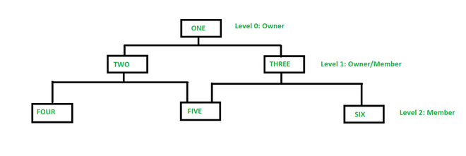
In the above figure, member TWO has only one owner ‘ONE’ whereas member FIVE has two owners i.e, TWO and THREE. Here, each link between the two record types represents 1 : M relationship between them. This model consists of both lateral and top-down connections between the nodes. Therefore, it allows 1: 1, 1 : M, M : N relationships among the given entities which helps in avoiding data redundancy problems as it supports multiple paths to the same record. There are various examples such as TOTAL by Cincom Systems Inc., EDMS by Xerox Corp., etc.
Example : Network model for a Finance Department.
Below we have designed the network model for a Finance Department:
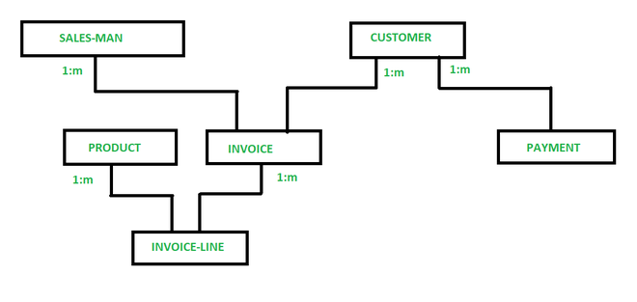
So, in a network model, a one-to-many (1: N) relationship has a link between two record types. Now, in the above figure, SALES-MAN, CUSTOMER, PRODUCT, INVOICE, PAYMENT, INVOICE-LINE are the types of records for the sales of a company. Now, as you can see in the given figure, INVOICE-LINE is owned by PRODUCT & INVOICE. INVOICE has also two owners SALES-MAN & CUSTOMER.
Let’s see another example, in which we have two segments, Faculty and Student. Say that student John takes courses both in CS and EE departments. Now, find how many instances will be there?
For the above mentioned, a student instance of time can have at least two parent instances therefore there are relations between the instances of students and faculty segment. The model can be very complex as if we use other segments say Courses and logical associations like Student-Enroll and Faculty-course. Therefore, under this model, a student can be logically related to different occurrences of Faculties and Courses.

Advantages of Network Model
- This model is very simple and easy to design like the hierarchical data model.
- This model is capable of handling multiple types of relationships which can help in modeling real-life applications, for example, 1: 1, 1: M, M: N relationships.
- In this model, we can access the data easily, and also there is a chance that the application can access the owner’s and the member’s records within a set.
- This network does not allow a member to exist without an owner which leads to the concept of Data integrity.
- Like a hierarchical model, this model also does not have any database standard,
- This model allows to represent multi parent relationships.

Disadvantages of Network Model
- The schema or the structure of this database is very complex in nature as all the records are maintained by the use of pointers.
- There’s an existence of operational anomalies as there is a use of pointers for navigation which further leads to complex implementation.
- The design or the structure of this model is not user-friendly.
- This model does not have any scope of automated query optimization.
- This model fails in achieving structural independence even though the network database model is capable of achieving data independence.

Features of Network Model in DBMS
- Data Relationship Representation: The network model uses a graph structure to represent data relationships. It allows many-to-many relationships, providing greater flexibility in how data is connected.
- Records and Sets: Data in a network model is organized into records and sets. Records are similar to rows in a relational table, and sets are used to define relationships between records, akin to links in a graph.
- Owner-Member Relationships: The network model defines data relationships using owner-member pairs. An owner record can be linked to multiple member records, and a member record can belong to multiple owner records, facilitating complex relationships.
- Navigational Access: The network model supports navigational data access, where records are accessed through predefined paths. This is different from relational models, which use declarative query languages like SQL.
- Hierarchical and Non-Hierarchical Structures: The network model can represent both hierarchical (tree-like) and non-hierarchical (graph-like) structures, providing flexibility in data modeling.

Limitations of Network Model in DBMS
- Complex database design requires significant pre-planning and intricate schema development involving high-level technical capabilities.
- Structural Rigidity makes changes to the database structure very difficult and complex.
- The complexity of programming requires advanced programming skills for database manipulation and navigation.
- Least Data Independence: Coupling between Physical and Logical Data Dependencies gets tight.
- Performance Overhead is the consumption of computational resources in record navigation and data retrieval.

Operations on Network Model in DBMS
- Insertion: Adding new records and establishing owner-member relationships.
- Deletion: Removing records and maintaining data integrity by handling related records and relationships.
- Update: Modifying existing records and relationships between records.
- Traversal: Navigating through the network structure to access related records using predefined paths.
- Search: Retrieving specific records based on criteria by navigating the network structure.

Conclusion
The network model in DBMS provides an adaptive way to represent complex data relationships with its graph-based structure. Although it can support many-to-many relationships and more complex data interconnectivity than the hierarchical model, it also needs more advanced navigational access methods. Its features and operations are known to enable one to exploit its use for scenarios that involve complicated data interactions.
OTHER REFRENCES
- https://www.geeksforgeeks.org/network-model-in-dbms/
- https://www.tutorialspoint.com/explain-the-network-model-in-dbms
- https://db-book.com/db6/appendices-dir/d.pdf
- https://www.scaler.com/topics/network-model-in-dbms/
SUGGESTED BOOK REFERENCES
- Ramakrishnan, R., & Gehrke, J. (2003). Database Management Systems (3rd ed.). McGraw-Hill Education.
- Elmasri, R., & Navathe, S. B. (2015). Fundamentals of Database Systems (7th ed.). Pearson.
- Hernandez, M. J. (2013). Database Design for Mere Mortals: A Hands-On Guide to Relational Database Design (3rd ed.). Addison-Wesley Professional.

